**Aim:** To obtain the best fit line over multiple featurescattered datapoints using Linear Regression

**IDE:** Google Colab

**Theory:**

Multiple linear regression (MLR), also known simply as multiple regression, is a statistical technique that uses several explanatory variables to predict the outcome of a response variable. The goal of multiple linear regression is to model the [linear relationship](https://www.investopedia.com/terms/l/linearrelationship.asp) between the explanatory (independent) variables and response (dependent) variables. In essence, multiple regression is the extension of ordinary least-squares (OLS) regression because it involves more than one explanatory variable.

**Formula and Calculation of Multiple Linear Regression**

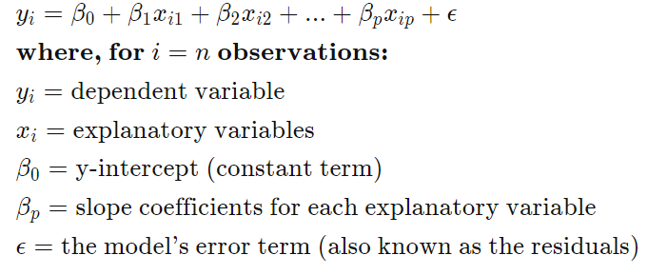

**Example of How to Use Multiple Linear Regression**

As an example, an analyst may want to know how the movement of the market affects the price of ExxonMobil (XOM). In this case, their linear equation will have the value of the S&P 500 index as the independent variable, or predictor, and the price of XOM as the dependent variable.

In reality, multiple factors predict the outcome of an event. The price movement of ExxonMobil, for example, depends on more than just the performance of the overall market. Other predictors such as the price of oil, interest rates, and the price movement of oil [futures](https://www.investopedia.com/terms/f/futures.asp) can affect the price of XOM and stock prices of other oil companies. To understand a relationship in which more than two variables are present, multiple linear regression is used.

Multiple linear regression (MLR) is used to determine a mathematical relationship among several random variables. In other terms, MLR examines how multiple independent variables are related to one dependent variable. Once each of the independent factors has been determined to predict the dependent variable, the information on the multiple variables can be used to create an accurate prediction on the level of effect they have on the outcome variable. The model creates a relationship in the form of a straight line (linear) that best approximates all the individual data points.

**Program (Code):**

1. Load the basic libraries and packages
2. Load the dataset
3. Analyse the dataset
4. Normalize the data
5. Pre-process the data
6. Visualize the Data
7. Separate the feature and prediction value columns
8. Write the Hypothesis Function
9. Write the Cost Function
10. Write the Gradient Descent optimization algorithm
11. Apply the training over the dataset to minimize the loss
12. Find the best fit line to the given dataset
13. Observe the cost function vs iterations learning curve

**Results:**

To be attached with

1. 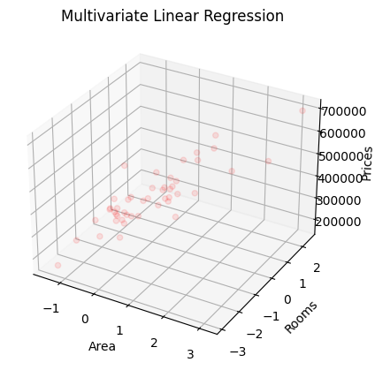Datapoints scattering (without best fit line)
2. Data Statistics before Normalization

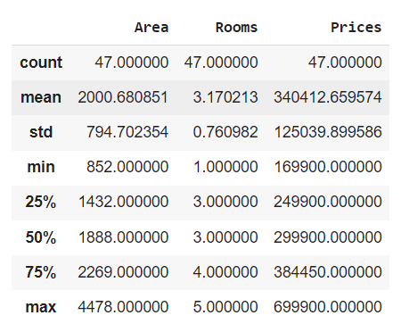

1. 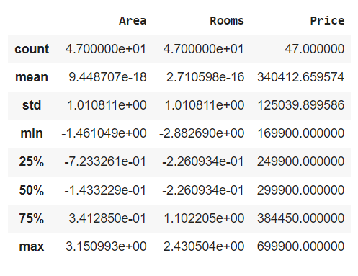Data Statistics after Normalization
2. Learning Curve (Cost function vs iterations)

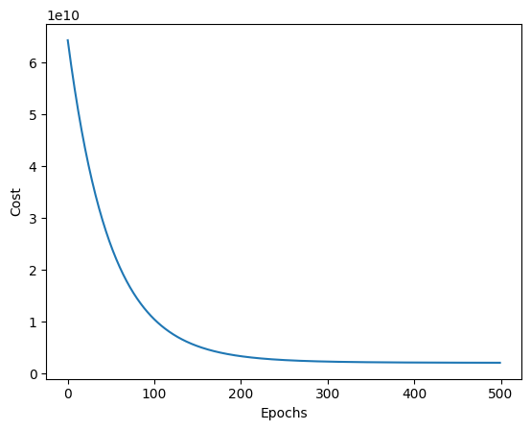

**Observation and Result Analysis:**

1. Nature of the dataset

________________________________________________________________________________________________________________________________________________________________________________________________________________________________________________________________________________________________

1. During Training Process

________________________________________________________________________________________________________________________________________________________________________________________________________________________________________________________________________________________________

1. After the training Process

________________________________________________________________________________________________________________________________________________________________________________________________________________________________________________________________________________________________

1. Observation over the Learning Curve

________________________________________________________________________________________________________________________________________________________________________________________________________________________

**Post Lab Exercise:**

1. What is the difference between single and multiple variable linear regression

________________________________________________________________________________________________________________________________________________________________________________________________________________________

## What does it mean for a multiple linear regression to be linear?

________________________________________________________________________________________________________________________________________________________________________________________________________________________

1. What is the use of Normalization?

________________________________________________________________________________________________________________________________________________________________________________________________________________________

1. Is there any change in the behavior of data before and after normalization? Prove using a toy example.

**Post Lab Activity:**

Consider any dataset from **https://archive.ics.uci.edu/ml/datasets** and perform the multiple variable linear regression analysis over the dataset and obtain the best fit line. Make sure that the dataset is not matching with your classmates. You can also select the dataset from other ML repositories with prior permission from your concerned subject faculty.